**Abstract**

For this lab we were tasked with developing various different circuit elements that would perform as expected for us. The first component was a 2-to-1 multiplexer with a select input. The next component was a Fibonacci verifier. This component takes in a four-bit input and outputs a logic one or zero for true or false. The next component determines the next Fibonacci number based on a four-bit input. The output is five-bits instead of four since we need to consider the value 21 being the next Fibonacci value after 13. The final portion is to combine all of the previous components to develop a system that can determine either the current or next Fibonacci number and display it on the 7-segment display. In addition to this, an LED will light up if the four-bit input is a Fibonacci number.

**Body of the Report**

Introduction

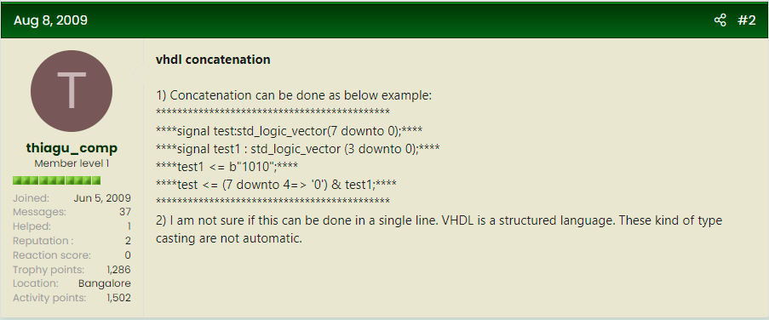

…

Conclusion